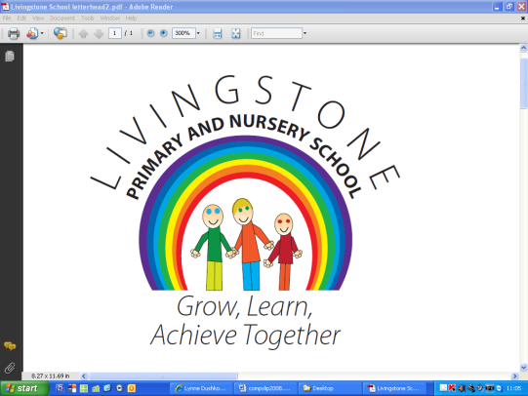

Livingstone Newsletter

28th June 2024

Star of the Week:

Nursery: Brayden Reception: Georgina Year 1: Willow Year 2: Cole

Year 3: Aaron Year 4: Olly Year 5: Lucas Year 6: Jade

Well done to all our Stars of the Week!

Clubs:

All clubs are on next week.

Tuesday: Boardgames, History, Lego, Multisports Y1/2

Wednesday: Multisports Y5/6

Thursday: Science, Sewing, Balance bikes, Debate

School Streets Trial:

Thank you for all the positive comments about the introduction of the School Streets scheme.

**However, to keep this going sustainably, we really do need more volunteers. If you like the scheme and want it to continue, please consider if you could spare one day 8.25am – 9.00am or 2.45 – 3.20pm.** Full training is given and Little Stones take children of volunteers for free.

If you wish to complain about the scheme, the email is [trafficoperations@tameside.gov.uk](mailto:trafficoperations@tameside.gov.uk)

Sports Day:

We had a lovely day at Sports day on Wednesday. The winning teams were:

EYFS & KS1: Red team

KS2: Blue team

Well done to everyone for your efforts and sporting behaviour, whether your team won or not.

Tuesday 2nd July – Year 6 brass concert:

Year 6 children who play brass at school are invited up to Mossley Hollins to perform alongside children from Milton who also learn brass as part of the Mossley and Carrbrook Schools Partnership. They will also perform with the Mossley Hollins band.

Children will walk up in the afternoon, after an early lunch, for a rehearsal and will stay at MHHS until a concert at 4pm which is expected to last about 45 minutes. Each child will be allocated two tickets for the concert. They should then be collected from MHHS at 4.45pm.

Classes for next year:

Nursery: Mrs Dawson & Mrs Miller

Reception: Ms Sellers

Year 1: Mrs Davies & Mrs Marshall

Year 2: Miss Mathews

Year 3: Mrs Coulter & Miss Docherty

Year 4: Mrs Legge

Year 5: Miss Keating

Year 6: Mrs Bromley & Mr Flint

All children will be spending most of the morning with their new class teachers on Friday 5th July.

Parking:

Even though parking is now further away from school, can I remind parents and carers to park with consideration to those residents who live further up Old Brow – please ensure that you are not blocking residents’ drives even for a few minutes.

After the Diary Dates, I have attached a few flyers.

Dates for your diary:

Tuesday 2nd July: Year 6 to Brass celebration at MHHS with other schools and concert 4pm

Thurs 4th July: Year 6 transition to Copley and MHHS

Fri 5th July: Year 6 transition to MHHS

In school transition and new EYFS 9.15 – 10.15am

Mon 8th – Wed 10th July: Robinwood

Monday 8th July: Incredible Edible Mossley session with Year 4

Thursday 11th July: Year 5 educational visit to Manchester Museum

Friday 12th July: End of Year reports out

Monday 15th July: Mossley Primary Olympics

Wednesday 17th July: End of year celebration evening – parents invited to school to look at work

Wed 17th&Thurs 18th July: Year 6 performance 6.30pm

Thursday 18th July: Reception Pirate Day with visiting pirate

Thursday 25th July: Year 6 leavers’ do 5.30 – 7.30pm

Friday 26th July: Year 6 leavers’ assembly 2pm

End of term 3.15pm

Monday 2nd September: INSET Day for staff

Tuesday 3rd September: Children return to school

